Project Design Phase-II
Data Flow Diagram & User Stories

Date | 14 July 2026
Team ID
Project Name | HH-01
Maximum Marks | 04

Data Flow Diagrams:
The Data Flow Diagram (DFD) illustrates how information flows through the HouseHunt – House Rental Application. It shows the interaction between Tenants, Owners/Admin, the HouseHunt system, and the MongoDB database.
Example: DFD Level 0 (Industry Standard)

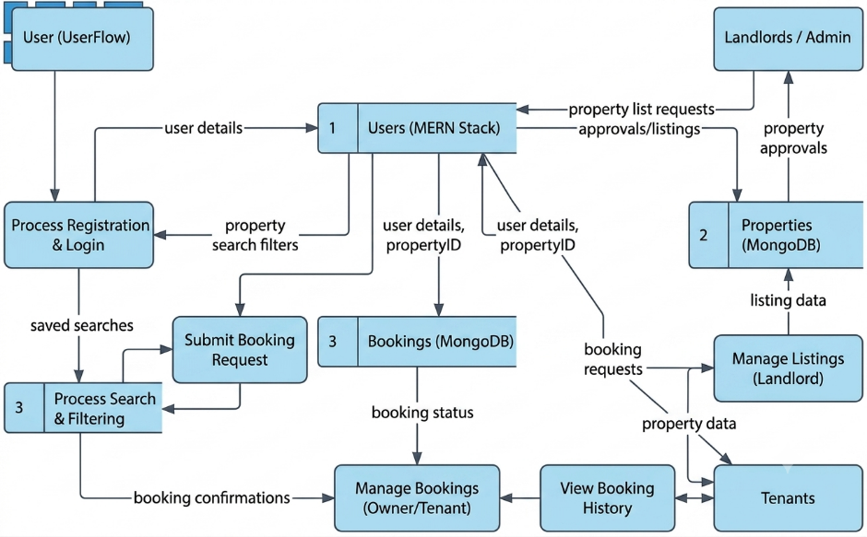

User Stories
Use the below template to list all the user stories for the product.
User Type | Functional Requirement (Epic) | User Story Number | User Story / Task | Acceptance criteria | Priority | Release
Customer (Mobile user) | Registration | USN-1 | As a user, I can register for the application by entering my email, password, and confirming my password. | I can access my account / dashboard | High | Sprint-1
 |  | USN-2 | As a user, I will receive confirmation email once I have registered for the application | I can receive confirmation email & click confirm | High | Sprint-1
 |  | USN-3 | As a user, I can register for the application through Facebook | I can register & access the dashboard with Facebook Login | Low | Sprint-2
 |  | USN-4 | As a user, I can register for the application through Gmail |  | Medium | Sprint-1
 | Login | USN-5 | As a user, I can log into the application by entering email & password |  | High | Sprint-1
 | Dashboard
Customer (Web user)
Customer Care Executive
Administrator

HouseHunt Data Flow Diagram (Level 0)
+---------+ +--------------------+ +-------------+
| Tenant | -----> | HouseHunt System | <----- | Owner |
+---------+ | Login/Search/Book | +-------------+
+--------------------+
|
v
+--------------------+
| MongoDB Database |
| Users Properties |
| Bookings History |
+--------------------+
^
|
+----------+
| Admin |
+----------+

HouseHunt User Stories
User | Epic | No | Story | Acceptance | Priority | Release
Tenant | Registration | USN-1 | Register account | Account created | High | Sprint-1
Tenant | Login | USN-2 | Login | Dashboard opens | High | Sprint-1
Tenant | Search | USN-3 | Search houses | Results shown | High | Sprint-1
Tenant | Booking | USN-4 | Book property | Pending booking | High | Sprint-2
Owner | Approval | USN-5 | Request owner approval | Owner verified | High | Sprint-1
Owner | Property | USN-6 | Manage properties | CRUD works | High | Sprint-2
Owner | Bookings | USN-7 | Approve/reject bookings | Status updated | High | Sprint-2
Admin | Verification | USN-8 | Approve owners | Owner active | High | Sprint-1
Admin | Management | USN-9 | Manage users/listings | Platform secure | Medium | Sprint-2

User Flow
Start -> Register/Login -> Search Property -> View Details -> Send Booking Request -> Owner Approves/Rejects -> Booking Status Updated -> End

